Introduction to Computer Networks Labsheet2

Analyzing the Web pages accessed using Wireshark
Part1: Mapping the given URL to IP address using nslookup
To run nslookup in Linux/Unix, you just type the nslookup command on the command line. To run it in Windows, open the Command Prompt and run nslookup on the command line.
We as humans usually use the website address known as Uniform Resource Locator (URL) to identify the destination host. But IP address is used by the devices to identify the server in the network. Domain Name System (DNS) service by the DNS server helps the client to translate an unknown URL to an IP address and also cache it in the device itself for subsequent access. The local cache maintains DNS record having a map between URL and IP address.

In it is most basic operation, nslookup tool allows the host running the tool to query any specified DNS server for a DNS record. To accomplish this task, nslookup sends a DNS query to the specified DNS server, receives a DNS reply from that same DNS server, and displays the result.
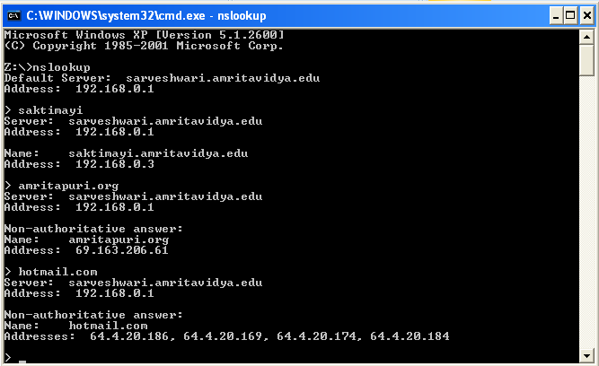
The IP address of abc.com is 18.67.161.122
The IP address of google.com is 142.250.182.142
Find the IP address of all websites that you are using for Part2.

Part2: Understanding the TCP/IP protocol stack using Wireshark

Layer | Protocol | Important Contents (You can get details on clicking on a packet) | Purpose of the content specified in the Layer
Application | DNS | 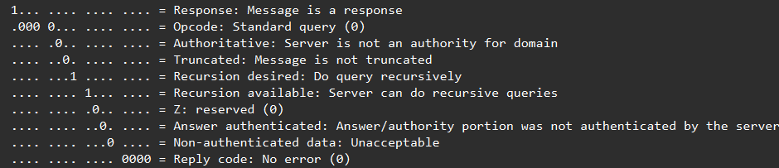
Transport | TCP | 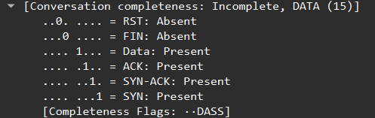
Network | ICMPv6 | 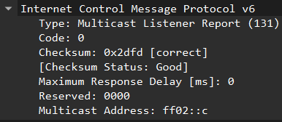
Data Link | Ethernet | 